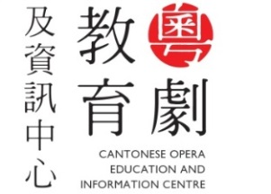
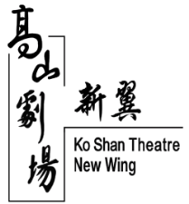

預約參觀登記表格 Registration Form for Visit
請於辦公時間內致電2330 5130 / 2330 5473預約參觀或將填妥的申請表格傳真（2781 4783）或郵寄至中心（地址：香港紅磡高山道77號高山劇場新翼三樓）。名額有限，先到先得。
For reservation, please call 2330 5130 / 2330 5473 during the office hours or submit the completed form either by fax (2781 4783) or by post (Address: 3/F Ko Shan Theatre New Wing, 77 Ko Shan Road, Hung Hom, Hong Kong). Registration is made on a first-come, first-served basis.

姓名（中文） |  | Name（English）
電話 Tel No. |  | 電郵 Email
擬參觀日期  Preferred Date of Visit | - ____/____/____ (日DD/月MM/年YY) |  |  | - ____/____/____ (日DD/月MM/年YY)
擬參觀時間（星期一、三至五）  Preferred Time of Visit (Mon, Wed to Fri) | 13:00-15:00  18:00-20:00 |  | 15:30-17:30 | 13:00-15:00  18:00-20:00 | 15:30-17:30
擬參觀時間（星期六、日及公眾假期）  Preferred Time of Visit (Sat, Sun and Public Holidays only) | 10:30-12:30  15:30-17:30 |  | 13:00-15:00  18:00-20:00 | 10:30-12:30  15:30-17:30 | 13:00-15:00  18:00-20:00
請在合適空格加上「」。Please put a “”in the appropriate box.

日期 Date |  | 簽署 Signature
個人資料收集聲明 Personal Information Collection Statement
透過本表格所提供的個人資料只供作高山劇場之用，並會存檔作記錄。根據個人資料（私隱）條例第18及22條及附表1內第6項原則，閣下有權要求查閱及改正本表格所載的個人資料。如欲查閱及更正本表格所收集的個人資料，請致電2330 5473與高山劇場副經理（九龍西）市場推廣及地區活動聯絡。
Personal data provided in this form will be used by Ko Shan Theatre only and kept as records of the theatre. In accordance with Section 18, 22 and Principle 6 of Schedule 1 to the Personal Data (Privacy) Ordinance, you have the right to request access to and make correction of personal date as stated in this form. Enquiries concerning the personal data collected in this form, including the request for access and corrections, please contact AM(KW)MPDA at 2330 5473.

備註 Remarks
- 中心將以電話覆實參觀日期及時間。
Actual date and time of visit will be confirmed by phone.
- 查詢 Enquiry
辦公時間： 星期一至五 上午九時至下午六時
Office hours: Mon to Fri 9 am to 6 pm
電話 Tel：2330 5130 / 2330 5473 傳真 Fax：2781 4783
電郵 E-mail：csocoeic1@lcsd.gov.hk / amkwmpda@lcsd.gov.hk

